Reference: Light and Optics
Difficulty: easy
Learning Objective: None
Contest: 1997

Light, like any other wave, obeys the Universal Wave Equation. What is the frequency of light with a wavelength of 500 nm in a vacuum?

DATA:

speed of light in vacuum = 3.00 × 10⁸ m/s
1.00 nm = 1.00 × 10⁻⁹ m

A) 1.67 × 10⁻¹⁵ Hz
B) 5.00 × 10⁻⁷ Hz
C) 1.50 × 10² Hz
D) 8.00 × 10⁵ Hz
E) 6.00 × 10¹⁴ Hz

Answer: E
Reference: Light and Optics
Difficulty: easy
Learning Objective: None
Contest: 1997

A beam of red laser light strikes a glass surface so that some reflects and the rest travels into the glass or refracts. If we compare this refracted beam to the original incident beam, which of the following quantities has not changed?

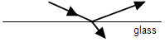

A) frequency
B) power
C) direction
D) speed
E) wavelength

Answer: A
Reference: Light and Optics
Difficulty: easy
Learning Objective: None
Contest: 1997

A fluorescent light tube of length 100 cm is positioned horizontally on the ceiling, 3.0 m above the floor. An opaque stick of length 60 cm is held parallel to the light tube, directly beneath it and casts its shadow on the floor. At what minimum height above the floor will the shadow of the stick be penumbra only?

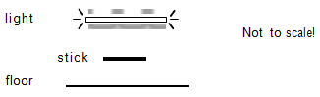

A) 0.60 m
B) 1.2 m
C) 1.8 m
D) 2.4 m
E) 2.8 m

Answer: C
Reference: Light and Optics
Difficulty: moderate
Learning Objective: None
Contest: 1997

You have two converging lenses of the same diameter. Lens X has a focal length of 20 cm, while lens Y has a focal length of 200 cm. On a sunny day, shining onto identical pieces of paper, both lenses are used to form a focussed image of the sun on the papers. Which lens will cause the paper to start burning first, and for what reason?

A) Both will start at the same time; since they have the same diameter and collect the same sunlight.
B) X will start first; since its image is closer, the image of the sun will be smaller and thus more concentrated.
C) Y will start first; since its image is further away the image of the sun will be smaller and thus more concentrated.
D) X will start first; since there is less light absorbed than Y in the short air path from lens to paper.
E) Y will start first; since X will suffer severe chromatic aberration.

Answer: A
Reference: Light and Optics
Difficulty: easy
Learning Objective: None
Contest: 1998

A light ray is shone from the bottom of a tank, through water of index of refraction 1.3 and emerges to hit position C. If a thin layer of transparent oil with index of refraction 1.5 is point on the surface, which position would the light ray hit now? (You may assume that no internal reflection occurs.)

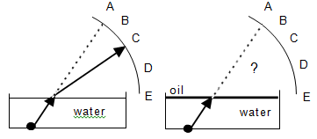

A) A
B) B
C) C
D) D
E) E

Answer: C
Reference: Light and Optics
Difficulty: easy
Learning Objective: None
Contest: 1998

When light goes from air to water (n = 1.3)

A) the frequency increases
B) the wavelength increases
C) the speed increases
D) the amplitude increases
E) none of the above

Answer: E
Reference: Light and Optics
Difficulty: easy
Learning Objective: None
Contest: 1998

A terrestrial telescope has a minimum of three lenses: an objective lens, an erecting lens and an eyepiece lens. Kelly has three convex lenses of focal lengths 2.0 cm, 10 cm and 100 cm. In order to construct the telescope of maximum magnification, in what order should she put the lenses, from front to eye?

A) 2.0 cm, 10 cm, 100 cm
B) 2.0 cm, 100 cm, 10 cm
C) 100 cm, 10 cm, 2.0 cm
D) 100 cm, 2.0 cm, 10 cm
E) 10 cm, 2.0 cm, 100 cm

Answer: C
Reference: Light and Optics
Difficulty: easy
Learning Objective: None
Contest: 1999

Which word fits best? Pitch is to sound as ________ is to light.

A) colour
B) brightness
C) speed
D) amplitude
E) intensity

Answer: A
Reference: Light and Optics
Difficulty: easy
Learning Objective: None
Contest: 1999

A single converging lens forms an image of a candle on a screen as shown below.

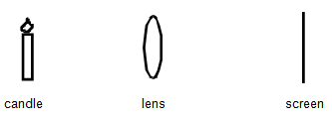

If the bottom half of the lens is now covered, the image on the screen will:

A) only show the top half of the candle.
B) only show the bottom half of the candle.
C) show all of the candle.
D) not show an image of the candle at all.
E) become out of focus.

Answer: C
Reference: Light and Optics
Difficulty: easy
Learning Objective: None
Contest: 1999

A light ray travels through three different media in the path shown below.
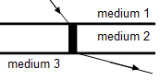

If v represents the speed of light then which of the following relationships is correct?

A) v₁ > v₂ > v₃
B) v₁ > v₃ > v₂
C) v₃ > v₂ > v₁
D) v₃ > v₁ > v₂
E) v₂ > v₁ > v₃

Answer: D
Reference: Light and Optics
Difficulty: easy
Learning Objective: None
Contest: 1999

Zircon has a critical angle of 31°. Total internal reflection occurs when light is incident

A) from air to zircon at an incident angle of 31°.
B) from air to zircon at an incident angle of > 31°.
C) from air to zircon at an incident angle of < 31°.
D) from zircon to air at an incident angle of > 31°.
E) from zircon to air at an incident angle of < 31°.

Answer: D
Reference: Light and Optics
Difficulty: easy
Learning Objective: None
Contest: 1999

Consider what you would see if a large rectangular block of glass were placed on this exam, between your eyes and the words. The block has parallel flat side. Compared to originally, the test would now appear:

A) exactly as it did before.
B) further away and the printing smaller.
C) further away and the printing larger.
D) closer to you and the printing smaller
E) closer to you and the printing larger.

Answer: E
Reference: Light and Optics
Difficulty: easy
Learning Objective: None
Contest: 2000

A converging lens is used to form an image of a candle placed in front of it. The resulting image is inverted and the same size. The lens is then replaced with one identical to it in physical dimension, but of higher index of refraction. After refocussing, the new image is

A) the same size
B) larger in size
C) smaller in size
D) larger or smaller depending on how much the index changed
E) non-existent, depending on how much the index changed

Answer: C
Reference: Light and Optics
Difficulty: easy
Learning Objective: None
Contest: 2000

Two converging lenses have the same focal length, but lens X has a diameter of 10 cm, while lens Y has a diameter of 5 cm. Both lenses are used separately to form an image of a faraway tree. Compare the two images produced.

A) Lens X produces a larger image of the tree than lens Y, and brighter.
B) Lens X produces a larger image of the tree than lens Y, but of the same brightness.
C) Lens X produces the same size image of the tree as lens Y, but brighter.
D) Lens X produces the same size image of the tree as lens Y, and of the same brightness.
E) Lens X produces a smaller image of the tree than lens Y, but much brighter.

Answer: C
Reference: Light and Optics
Difficulty: moderate
Learning Objective: None
Contest: 2000

A parallel beam of light is travelling underwater, when it encounters a large spherical bubble of air. After the beam leaves the bubble, it will

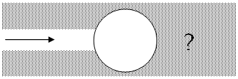

A) diverge
B) converge
C) remain parallel, with the same width
D) remain parallel but be wider
E) remain parallel but be narrower

Answer: A
Reference: Light and Optics
Difficulty: easy
Learning Objective: None
Contest: 2000

In viewing the primary rainbow, the sun is usually at one’s back as it strikes water droplets in front of you. In order to produce the rainbow, sunlight need only

A) reflect
B) refract
C) diffract
D) A and B
E) A, B and C

Answer: D
Reference: Light and Optics
Difficulty: moderate
Learning Objective: None
Contest: 2001

What must be the minimum length of a vertical plane mirror in order for you to see a full view of yourself?

A) ¼ your height
B) ½ your height
C) ¾ your height
D) your full height
E) The answer depends on your distance from the mirror.

Answer: B
Reference: Light and Optics
Difficulty: easy
Learning Objective: None
Contest: 2001

Several lenses with the same diameter are shown below. Which of these lenses would bring a beam of light to a spot closest to the lens?

A) B) C) D) E)
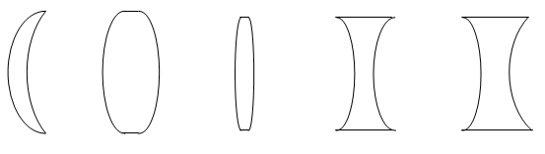

Answer: B
Reference: Light and Optics
Difficulty: difficult
Learning Objective: None
Contest: 2001

Suppose that Albert Michelson set up his octogonal rotating mirror to measure the speed of light. Suppose further that he used a reflecting mirror 36.0 km away. What is the minimum number of revolutions per second required of the rotating mirror?

A) 8330
B) 4168
C) 1040
D) 521
E) 260

Answer: B
Reference: Light and Optics
Difficulty: easy
Learning Objective: None
Contest: 2002

On a clear and sunny day you are on snow and you look at your shadow. You see that your shadow is tinted

A) no particular colour.
B) red.
C) yellow.
D) green.
E) blue.

Answer: E
Reference: Light and Optics
Difficulty: easy
Learning Objective: None
Contest: 2002

A student uses a magnifying glass to examine the crystals in a mineral sample. The magnifying glass contains a

A) diverging mirror
B) converging lens.
C) diverging lens.
D) converging mirror.
E) plane mirror.

Answer: B
Reference: Light and Optics
Difficulty: easy
Learning Objective: None
Contest: 2002

Maria showed slides by projecting them on a fixed screen. Her friend complained that the image was too small. Maria enlarged the image by moving the projector away from the screen, but the image blurred. The image should then have been brought into focus by

A) moving the lens closer to the slide.
B) moving the lens away from the slide.
C) decreasing the amount of light in the room.
D) increasing the power of the projector lamp.
E) it is not possible to focus the image.

Answer: A
Reference: Light and Optics
Difficulty: easy
Learning Objective: None
Contest: 2002

A neutral density filter is a filter which absorbs the same amount of each wavelength of light incident upon it. A certain neutral density filter absorbs 50% of the light incident upon it. Two layers of this filter will absorb

A) 100% of the light.
B) 75% of the light.
C) 67% of the light.
D) 50% of the light.
E) 25% of the light.

Answer: B
Reference: Light and Optics
Difficulty: easy
Learning Objective: None
Contest: 2002

The same frequency of monochromatic light is incident from air upon four lenses made of different materials but otherwise identical. The lens that has the longest focal length is made of

A) quartz (n=1.46).
B) lucite (n = 1.51).
C) crown glass (n = 1.54).
D) flint glass (n= 1.65).
E) there is not enough information.

Answer: A
Reference: Light and Optics
Difficulty: easy
Learning Objective: None
Contest: 2003

Which of the following quantities always stay(s) constant when light travels from one medium to another?

A) wavelength
B) speed
C) frequency
D) phase
E) all of these

Answer: C
Reference: Light and Optics
Difficulty: easy
Learning Objective: None
Contest: 2003

When you stand in front of a window at night in a lighted room, you can see lighted objects outside, as well as an image of yourself. The latter is due to

A) total internal reflection.
B) dispersion.
C) partial reflection.
D) refraction.
E) all of these.

Answer: C
Reference: Light and Optics
Difficulty: moderate
Learning Objective: None
Contest: 2003

A diverging lens has a focal length of -0.100 m. Distances are measured from the optical centre of the lens. John wishes to use this lens to create an image twice the height of the object. Which of the following statements is correct. He will be successful if he places the object

A) 0.12 m on the same side as the desired image.
B) 0.12 m on the side opposite the desired image.
C) 0.10 m on the same side as the desired image.
D) 0.10 m on the side opposite the desired image.
E) He will never be successful.

Answer: E
Reference: Light and Optics
Difficulty: easy
Learning Objective: None
Contest: 2003

In the diagram a parallel light beam enters a box. What is the best combination of shape and position for a glass lens inside the box?
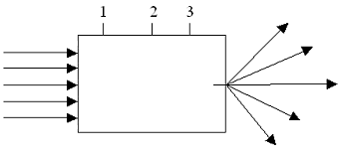

A) diverging lens at position 1
B) diverging lens at position 3
C) converging lens at position 1
D) converging lens at position 2
E) converging lens at position 3

Answer: E
Reference: Light and Optics
Difficulty: easy
Learning Objective: None
Contest: 2003

While picking up a pair of eyeglasses dropped by a friend, you notice that they form an inverted image of the background and that the image is stretched horizontally as well. Your friend suffers from

A) myopia and astigmatism.
B) hyperopia and astigmatism.
C) myopia only.
D) hyperopia only.
E) astigmatism only.

Answer: B
Reference: Light and Optics
Difficulty: easy
Learning Objective: None
Contest: 2004

Two prisms are used to make a periscope. Which of the following is the correct arrangement?

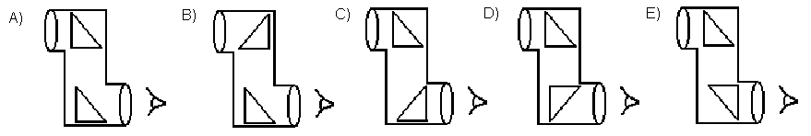

Answer: E
Reference: Light and Optics
Difficulty: moderate
Learning Objective: None
Contest: 2004

A fiber optic line is composed of a core with an index of refraction of 1.61 and cladding with an index of 1.38. The angle θ is the angle of incidence for a ray of light travelling in the core and incident on the core-cladding interface. Which one of the following relations best describes the angle θ that will result in total internal reflection within the fiber optic line?

A) θ < 59º
B) θ > 59º
C) θ < 31º
D) θ > 31º
E) 0 < θ < 90º

Answer: B
Reference: Light and Optics
Difficulty: moderate
Learning Objective: None
Contest: 2004

Determine the size and orientation of the image formed by the lens system shown. Each lens has a focal length of 8 cm. The diagram is not necessarily drawn to scale.

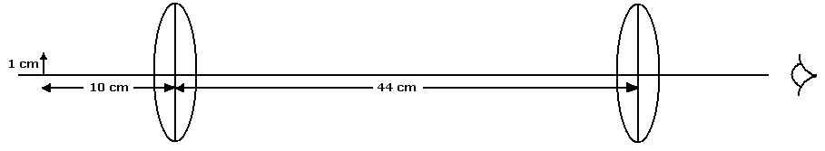

A) 4 cm, erect
B) 4 cm, inverted
C) 8 cm, erect
D) 8 cm, inverted
E) No image is formed

Answer: D
Reference: Light and Optics
Difficulty: moderate
Learning Objective: None
Contest: 2004

A fish sees the smiling face of a scuba diver through a bubble of air between them, as shown. Compared to the face of the diver, the image seen by the fish will be

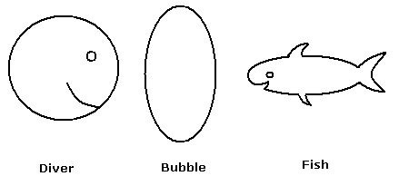

A) smaller and erect
B) smaller and inverted
C) larger and erect
D) larger and inverted
E) the same size and erect

Answer: A
Reference: Light and Optics
Difficulty: moderate
Learning Objective: None
Contest: 2004

A small candle is 1.00 m from a screen. A lens of focal length +10.0 cm is placed between the candle and the screen. There are two positions for the lens that will result in a sharp image of the candle on the screen. Find the distance between these two positions.

A) 11.3 cm
B) 52.2 cm
C) 77.5 cm
D) 88.7 cm
E) 91.4 cm

Answer: C
Reference: Light and Optics
Difficulty: moderate
Learning Objective: None
Contest: 2005

A scuba diver was lying “attached to” the bottom of an empty indoor swimming pool, looking up. The rays coming from the opposite edges of the pool made an angle of 90° at his eyes. If the pool is filled with water (n = 1.33) to a level of a few centimeters below the edges, submerging the diver, what angle will the edges form, as seen by the diver?

A) greater than 90°
B) exactly 90°
C) less than 90°
D) 0°
E) The diver will not be able to see the edges.

Answer: C
Reference: Light and Optics
Difficulty: moderate
Learning Objective: None
Contest: 2005

An object was placed 25 cm in front of a converging lens with a focal length of 20 cm. A concave mirror with a focal length of 15 cm was placed 120 cm behind the lens. Which of these describes the final image?

A) real, upright
B) virtual, upright
C) real, inverted
D) virtual, inverted
E) nverted, enlarged

Answer: A
Reference: Light and Optics
Difficulty: moderate
Learning Objective: None
Contest: 2005

Without her contact lenses, a student can focus an object located 0.80 m to infinity from her eyes. The power of a lens, measured in diopters, is the reciprocal of the focal length, measured in meters. Assuming that the image distance in the eye is 0.02 m, what lens power does she require for reading a text located 0.25 m from her eyes?

A) 1.25 diopters
B) 5.25 diopters
C) 5.25 diopters
D) 2.75 diopters
E) –2.75 diopters

Answer: D
Reference: Light and Optics
Difficulty: easy
Learning Objective: None
Contest: 2005

A student noticed a rainbow appearing in the sky. As he walked towards it, what happened to the apparent height of the rainbow above the ground?

A) It increased very slowly.
B) It increased very quickly.
C) It decreased very slowly.
D) It decreased very quickly.
E) It remained the same.

Answer: E
Reference: Light and Optics
Difficulty: moderate
Learning Objective: None
Contest: 2005

Prisms are often used in binoculars made with two converging lenses. They are used

A) to lengthen the optical path.
B) to ensure that the final image seen is erect.
C) because they absorb less light than mirrors.
D) to allow shorter "tubes" to be used.
E) for all these reasons.

Answer: E
Reference: Light and Optics
Difficulty: easy
Learning Objective: None
Contest: 2006

Five spheres are lined up in front of a plane mirror as shown. The observer will be able to see the reflection of:
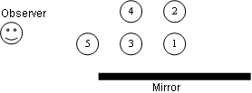

A) # 1 only
B) #5 only
C) #1 and #3 only
D) # 1,#2, #3 and #4 only
E) all of the spheres

Answer: A
Reference: Light and Optics
Difficulty: moderate
Learning Objective: None
Contest: 2006

A ray of light is normally incident on one face of a glass prism( n = 1.52) as shown. The prism is immersed in oil (n = 1.21). Find the maximum possible value of θ such that the ray is totally reflected internally in the prism.
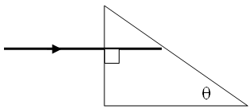

A) 23.6°
B) 37.2°
C) 52.8°
D) 66.4°
E) Total internal reflection is not possible for any θ.

Answer: B
Reference: Light and Optics
Difficulty:
Learning Objective: None
Contest: 2006

A scuba diver in an empty swimming pool uses a magnifier (n = 1.25) to enlarge the print on a plastic instruction sheet. If the pool is filled with water (n = 1.33), what happens to the magnification of the print?

A) It increases and is greater than one.
B) It stays the same.
C) It decreases, but is still greater than one.

D) It decreases and is less than one.
E) It is zero.

Answer: D
Reference: Light and Optics
Difficulty: easy
Learning Objective: None
Contest: 2006

The overall angular magnification of an astronomical telescope is 25X. The objective lens has a focal length of 80 cm. What is the focal length of the eyepiece?

A) 2.0 cm
B) 2.4 cm
C) 3.2 cm
D) 4.8 cm
E) 6.4 cm

Answer: C
Reference: Light and Optics
Difficulty:
Learning Objective: None
Contest: 2006

Two identical lenses are placed such that their focal points coincide as shown. Two parallel rays of light are sent into the first lens. After passing through the second lens, the two rays will
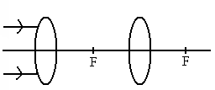

A) be parallel.
B) diverge.
C) converge and meet between the lens and the focal point.
D) converge and meet at the focal point.
E) converge and meet to the right of the focal point.

Answer: A
Reference: Light and Optics
Difficulty: Moderate
Learning Objective: None Sci10
Contest: 2007

A scuba diver takes a waterproof laser on a descent into calm fresh water with an index of refraction of 1.33. She aims the laser at the surface of the water such that the angle of incidence of the beam is 51.0º. What is the angle of refraction?

A) 0º
B) 35.8º
C) 51.0º
D) 90.0º
E) There is no angle of refraction because there is no refracted ray.

Answer: E
Reference: Light and Optics
Difficulty: Moderate
Learning Objective: None Sci10
Contest: 2007

Due to atmospheric refraction, the image of the sun rises _____ and sets _____ than the actual sun.

A) later, later
B) earlier, earlier
C) later, earlier
D) earlier, later
E) The answer depends on the location.

Answer: D
Reference: Light and Optics
Difficulty: Difficult
Learning Objective: None Sci10
Contest: 2007

An image of a bug is projected onto a screen using a converging lens of focal length 6.0 cm. The image of the bug is three times larger and inverted. How far apart are the bug and its image?

A) 8.0 cm
B) 12 cm
C) 16 cm
D) 24 cm
E) 32 cm

Answer: E
Reference: Light and Optics
Difficulty: Moderate
Learning Objective: None Sci10
Contest: 2007

A converging lens projects a real, inverted image of an object onto a screen. The bottom half of the lens is covered with an opaque material. How will the image change?

A) there will be no change
B) only the top half of the object will be seen
C) only the bottom half of the object will be seen
D) the image will be reduced in brightness
E) there will be no image

Answer: D
Reference: Light and Optics
Difficulty: Moderate
Learning Objective: None Sci 10
Contest: 2007

A student was asked to sketch a diagram to illustrate how a prism can form a spectrum on a screen. The student's diagram is shown. What corrections, if any, should be made?
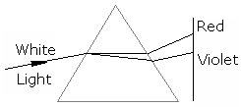

A) The diagram is correct.
B) The colours on the screen should be reversed.
C) The refraction at the first surface should be away from the normal.
D) The refraction at the second surface should be away from the normal.
E) The prism should be reversed vertically.

Answer: D
Reference: Light and Optics
Difficulty: Moderate
Learning Objective: None Sci10
Contest: 2008

A student stands in front of two plane mirrors joined at right angles, as shown, facing the junction of the mirrors. She raises her hand on side A. Which of the following will the student see straight ahead in the mirror?
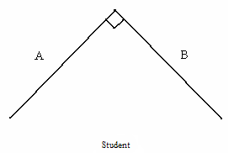

A) The image will raise the hand on side A.
B) The image will raise the hand on side B.
C) The image will raise both hands.
D) The image will raise neither hand.
E) The student will not see an image with this arrangement of the mirrors.

Answer: B
Reference: Light and Optics
Difficulty: Moderate
Learning Objective: None Sci10
Contest: 2008
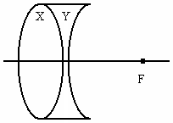
A double-convex lens X made of crown glass (n = 1.50) alone focuses a parallel beam of monochromatic red light at point F, as shown. A diverging lens made of flint glass (n = 1.91) is placed adjacent to the first lens, such that the combined lenses have a constant thickness. Where will the combined lenses focus a parallel beam of monochromatic red light?

A) The beam will not focus, but will diverge.
B) The beam will focus at point F.
C) The beam will focus closer to the lens than point F.
D) The beam will focus farther from the lens than point F.
E) The beam will not focus, but will remain parallel.

Answer: A
Reference: Light and Optics
Difficulty: Moderate
Learning Objective: None Sci10
Contest: 2008

Two adjoining facets on a diamond (n = 2.42) meet at an angle y. A ray of light inside the diamond strikes the middle of one facet at an angle x, as shown. It then reflects, and strikes the middle of the next facet at the same angle x, as shown. What is the minimum value of angle y such that the ray will reflect, rather than refract out of the diamond?

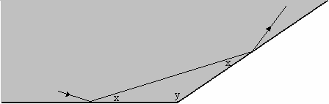

A) 48.8º
B) 32.5º
C) 24.4º
D) 21.7º
E) 12.2º

Answer: A
Reference: Light and Optics
Difficulty: Moderate
Learning Objective: None Sci 10
Contest: 2008

A point light source is placed at point O. Lens L₁ has a focal length of 10 cm. Light travels through L₁ to lens L₂, and leaves L₂ parallel to the axis, as shown. What is the focal length of lens L₂? Assume that both lenses can be considered as thin lenses. The diagram is not drawn to scale.
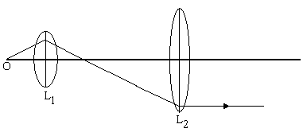

A) 10 cm
B) 20 cm
C) 30 cm
D) 40 cm
E) The focal length of L₂ cannot be determined from the information given.

Answer: A
Reference: Light and Optics
Difficulty: Difficult
Learning Objective: None Sci 10
Contest: 2008

The distance from the optical centre of a diverging lens to its focal point is represented by a. An object is placed a distance of 2a from the optical centre of the lens. What is the distance from the optical centre to the image?

A) 2a
B) a
C)
D)
E)

Answer: C
Reference: Light and Optics
Difficulty:
Learning Objective: None
Contest: 2009

A ray of light crosses from water (n = 1.33) to diamond (n = 2.42). For what angle of incidence will the angles of incidence and refraction be equal?

A) 0°
B) 30°
C) 45°
D) 60°
E) 90°

Answer: A
Reference: Light and Optics
Difficulty:
Learning Objective: None
Contest: 2009

A student sees the image of a spherical rock lying on the bottom of a pool of water. Which image will the student see?
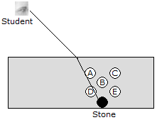

A) A
B) B
C) C
D) D
E) E

Answer: B

Reference: Light and Optics
Difficulty:
Learning Objective: None
Contest: 2009

The brightness of a diamond is due in large part to its high index of refraction (n = 2.42), which implies a small critical angle, and hence, a large amount of internal reflection. When travelling from diamond into air, which colour of light, of those shown, would have the smallest critical angle, and be most likely to reflect internally?

A) violet
B) green
C) yellow
D) red
E) all colours have the same critical angle in diamond

Answer: A
Reference: Light and Optics
Difficulty:
Learning Objective: None
Contest: 2009

An object, converging lens, and image are shown. Which of the three rays shown is not a ray that will help form the image? Note: the “thin lens” approximation has been used in the diagram.
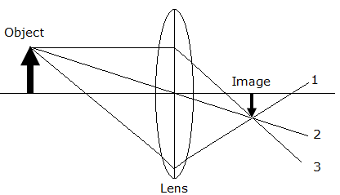

A) 1
B) 2
C) 3
D) 2 and 3
E) All 3 rays contribute to the image

Answer: E
Reference: Light and Optics
Difficulty:
Learning Objective: None
Contest: 2009

Light passing from a particular medium into a vacuum has a critical angle θ_{c}. Which of the relations shown relates the velocity of light in the medium, v, to the critical angle? Note: c is the velocity of light in a vacuum.

A) v = c sin θ_{c}
B) v = c tan θ_{c}
C) v = c / sin θ_{c}
D) v = c / tan θ_{c}
E) v = c / θ_{c}

Answer: A
Reference: Light and Optics
Difficulty:
Learning Objective: None
Contest:

A)
B)
C)
D)
E)

Answer:
Reference: Light and Optics
Difficulty:
Learning Objective: None
Contest:

A)
B)
C)
D)
E)

Answer:
Reference: Light and Optics
Difficulty:
Learning Objective: None
Contest:

A)
B)
C)
D)
E)

Answer:
Reference: Light and Optics
Difficulty:
Learning Objective: None
Contest:

A)
B)
C)
D)
E)

Answer:
Reference: Light and Optics
Difficulty:
Learning Objective: None
Contest:

A)
B)
C)
D)
E)

Answer:
Reference: Light and Optics
Difficulty:
Learning Objective: None
Contest:

A)
B)
C)
D)
E)

Answer:
Reference: Light and Optics
Difficulty:
Learning Objective: None
Contest:

A)
B)
C)
D)
E)

Answer:
Reference: Light and Optics
Difficulty:
Learning Objective: None
Contest:

A)
B)
C)
D)
E)

Answer:
Reference: Light and Optics
Difficulty:
Learning Objective: None
Contest:

A)
B)
C)
D)
E)

Answer:
Reference: Light and Optics
Difficulty:
Learning Objective: None
Contest:

A)
B)
C)
D)
E)

Answer:
Reference: Light and Optics
Difficulty:
Learning Objective: None
Contest:

A)
B)
C)
D)
E)

Answer:
Reference: Light and Optics
Difficulty:
Learning Objective: None
Contest:

A)
B)
C)
D)
E)

Answer:
Reference: Light and Optics
Difficulty:
Learning Objective: None
Contest:

A)
B)
C)
D)
E)

Answer:
Reference: Light and Optics
Difficulty:
Learning Objective: None
Contest:

A)
B)
C)
D)
E)

Answer:
Reference: Light and Optics
Difficulty:
Learning Objective: None
Contest:

A)
B)
C)
D)
E)

Answer:
Reference: Light and Optics
Difficulty:
Learning Objective: None
Contest:

A)
B)
C)
D)
E)

Answer:
Reference: Light and Optics
Difficulty:
Learning Objective: None
Contest:

A)
B)
C)
D)
E)

Answer:
Reference: Light and Optics
Difficulty:
Learning Objective: None
Contest:

A)
B)
C)
D)
E)

Answer:

Reference: Light and Optics
Difficulty:
Learning Objective: None
Contest:

A)
B)
C)
D)
E)

Answer:
Reference: Light and Optics
Difficulty:
Learning Objective: None
Contest:

A)
B)
C)
D)
E)

Answer:
Reference: Light and Optics
Difficulty:
Learning Objective: None
Contest:

A)
B)
C)
D)
E)

Answer:
Reference: Light and Optics
Difficulty:
Learning Objective: None
Contest:

A)
B)
C)
D)
E)

Answer:

Reference: Light and Optics
Difficulty:
Learning Objective: None
Contest:

A)
B)
C)
D)
E)

Answer:
Reference: Light and Optics
Difficulty:
Learning Objective: None
Contest:

A)
B)
C)
D)
E)

Answer:
Reference: Light and Optics
Difficulty:
Learning Objective: None
Contest:

A)
B)
C)
D)
E)

Answer:
Reference: Light and Optics
Difficulty:
Learning Objective: None
Contest:

A)
B)
C)
D)
E)

Answer:
Reference: Light and Optics
Difficulty:
Learning Objective: None
Contest:

A)
B)
C)
D)
E)

Answer:
Reference: Light and Optics
Difficulty:
Learning Objective: None
Contest:

A)
B)
C)
D)
E)

Answer:
Reference: Light and Optics
Difficulty:
Learning Objective: None
Contest:

A)
B)
C)
D)
E)

Answer:
Reference: Light and Optics
Difficulty:
Learning Objective: None
Contest:

A)
B)
C)
D)
E)

Answer:
Reference: Light and Optics
Difficulty:
Learning Objective: None
Contest:

A)
B)
C)
D)
E)

Answer:
Reference: Light and Optics
Difficulty:
Learning Objective: None
Contest:

A)
B)
C)
D)
E)

Answer:
Reference: Light and Optics
Difficulty:
Learning Objective: None
Contest:

A)
B)
C)
D)
E)

Answer:
Reference: Light and Optics
Difficulty:
Learning Objective: None
Contest:

A)
B)
C)
D)
E)

Answer:
Reference: Light and Optics
Difficulty:
Learning Objective: None
Contest:

A)
B)
C)
D)
E)

Answer:
Reference: Light and Optics
Difficulty:
Learning Objective: None
Contest:

A)
B)
C)
D)
E)

Answer:
Reference: Light and Optics
Difficulty:
Learning Objective: None
Contest:

A)
B)
C)
D)
E)

Answer:
Reference: Light and Optics
Difficulty:
Learning Objective: None
Contest:

A)
B)
C)
D)
E)

Answer:
Reference: Light and Optics
Difficulty:
Learning Objective: None
Contest:

A)
B)
C)
D)
E)

Answer:
Reference: Light and Optics
Difficulty:
Learning Objective: None
Contest:

A)
B)
C)
D)
E)

Answer:
Reference: Light and Optics
Difficulty:
Learning Objective: None
Contest:

A)
B)
C)
D)
E)

Answer:
Reference: Light and Optics
Difficulty:
Learning Objective: None
Contest:

A)
B)
C)
D)
E)

Answer:
Reference: Light and Optics
Difficulty:
Learning Objective: None
Contest:

A)
B)
C)
D)
E)

Answer:

Reference: Light and Optics
Difficulty:
Learning Objective: None
Contest:

A)
B)
C)
D)
E)

Answer:
Reference: Light and Optics
Difficulty:
Learning Objective: None
Contest:

A)
B)
C)
D)
E)

Answer:
Reference: Light and Optics
Difficulty:
Learning Objective: None
Contest:

A)
B)
C)
D)
E)

Answer:
Reference: Light and Optics
Difficulty:
Learning Objective: None
Contest:

A)
B)
C)
D)
E)

Answer:

